**Project Development Phase**

|  |  |
| --- | --- |
| **Date** | 02 November 2022 |
| **Team ID** | PNT2022TMID17570 |
| **Project Name** | Skill and Job Recommender Application |

**IBM REPOSITORY:**

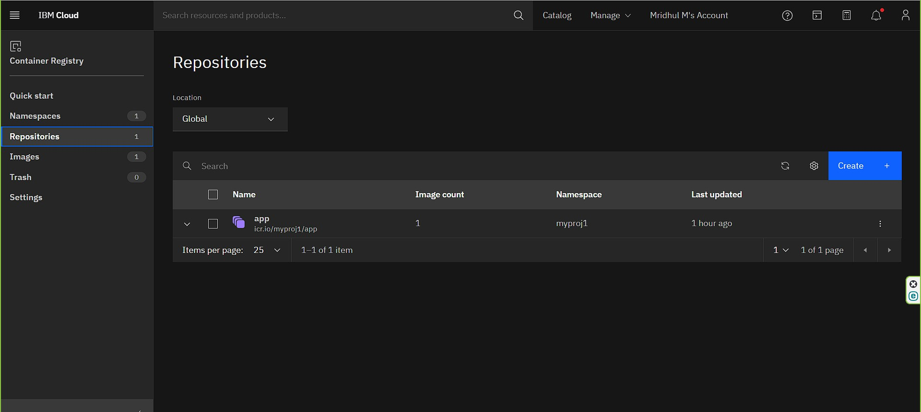

**UPLOAD IMAGE IN IBM REGISTRY:**

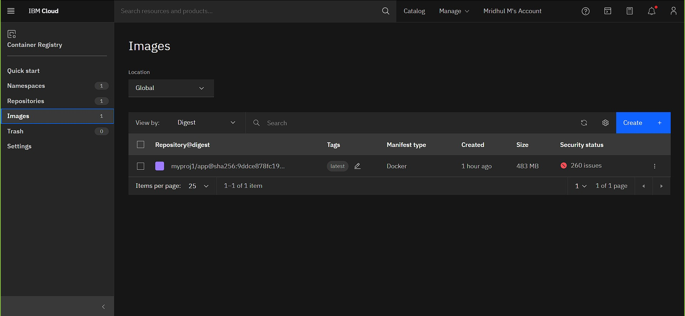

**KUBERNETES WORKER NODE:**

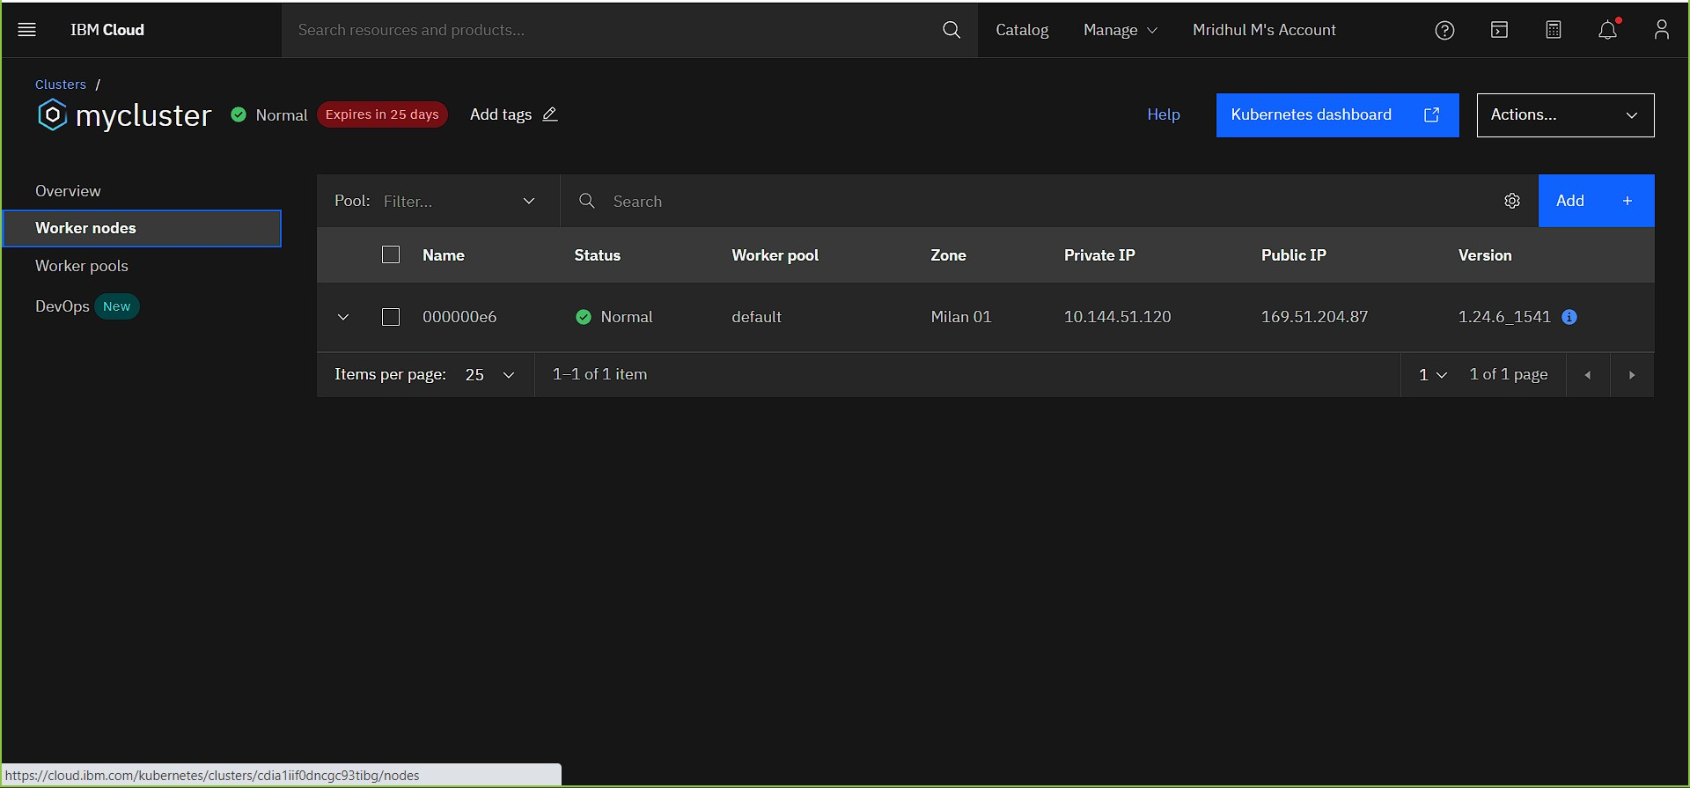

**KUBERNETE DEPLOYMENT:**

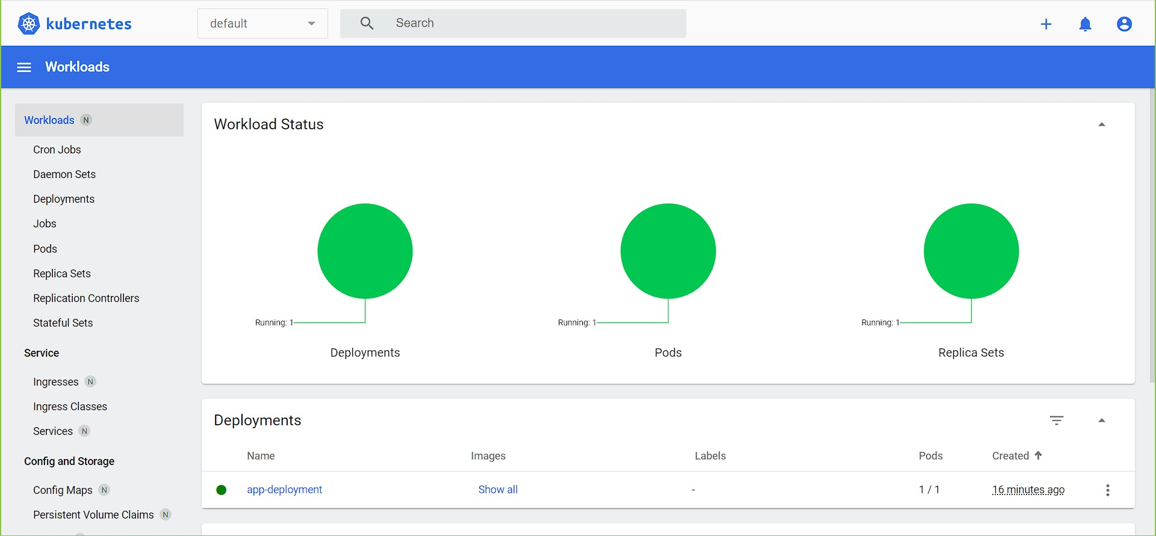

**KUBERNETE SERVICE PODS:**

